**Name- Tushar Chaudhary**

**Roll NO. – 2100290310152**

**Section – C**

**Subject- CS Lab**

**EXPERIMENT NO:-4**

***OBJECTIVE:*** Determine the transfer function for given closed loop system in block diagram representation.

***SOFTWARE REQUIRED:-*** MATLAB 2022

***THEORY :*** 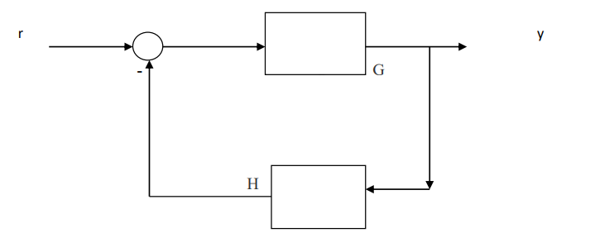

A block diagram is a graphical representation of a system that uses blocks to represent components and lines to show the connections between these components.

The transfer function of a system is a mathematical representation that relates the input to the output of the system in the frequency domain.

When analyzing a closed-loop system in block diagram representation, we aim to find the overall transfer function that describes the relationship between the input and output signals. This transfer function helps us understand the system's behavior and performance characteristics.

By applying block diagram algebra techniques, we can manipulate the blocks and signals in the diagram to simplify it and determine the transfer function of the closed-loop system.

This process involves combining blocks in series and parallel to derive the overall transfer function.

***Transfer Function:***

***TF=***



Let H = 2 and 𝐺 =

The corresponding MATLAB code :

K = 2; G = tf([1 2],[1 .5 3])

WE can compute the closed-loop transfer function TF from r to y in at least two ways:

1. Using the feedback command

2. Using the formula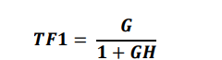

1. To compute TF using feedback, type TF1 = feedback(G,K)



1. ******To compute TF from the formula, type TF2 = G/(1+G*K)

***MATLAB CODE:***

K = 2;

G = tf([1 2],[1 .5 3])

TF1 = feedback(G,K)

TF2 = G/(1+G*K)

Z = [1 2];

z = roots(Z);

real_z = real(z);

imag_z = imag(z);

P = [1 2.5 7];

p = roots(P)

real_p = real(p);

imag_p = imag(p);

subplot(1,2,1)

plot(real_z,imag_z,'bo',real_p,imag_p,'g*')

hold on

title('plot of poles and zeroes TF1')

Z = [1 2.5 4 6] ;

z = roots(Z);

real_z = real(z);

imag_z = imag(z);

P = [1 3 11.25 11 21];

p = roots(P)

real_p = real(p);

imag_p = imag(p);

subplot(1,2,2)

plot(real_z,imag_z,'ro',real_p,imag_p,'b*')

title('plot of poles and zeroes TF2')

hold on

***RESULT:***

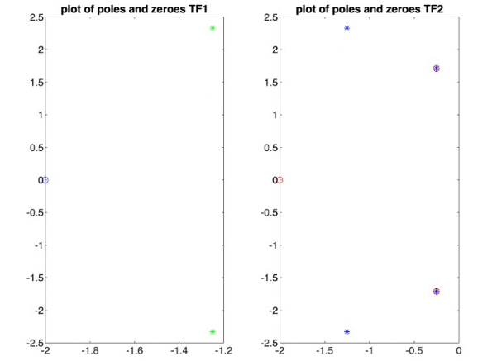

***Application:***

The applications of determining the transfer function for a closed-loop system are crucial in various fields like control systems, electronics, robotics, and more.

1. System Analysis: The transfer function helps in analyzing the behavior and stability of the system under different conditions.

2. Controller Design: It is used to design controllers that regulate the system's output to follow a desired reference signal.

3. Frequency Response Analysis: The transfer function aids in studying the system's response to different frequencies and disturbances.

4. Modeling and Simulation: Transfer functions are essential for modeling systems and simulating their behavior before implementing them in real-world applications.

5. Filter Design: In signal processing, transfer functions are used to design filters that modify the frequency content of signals.

6. System Identification: Transfer functions are used to identify the dynamic behavior of a system based on input-output data.